

**NETWORKING&SYSTEM ADMINISTRATION LAB**

**Experiment No.: 6**

**Aim**

Familiarization of basic linux commands

**Procedure:**

1.cp – cp command used to copy

**syntax:**

**$**cp flower flowerlist

**output:**

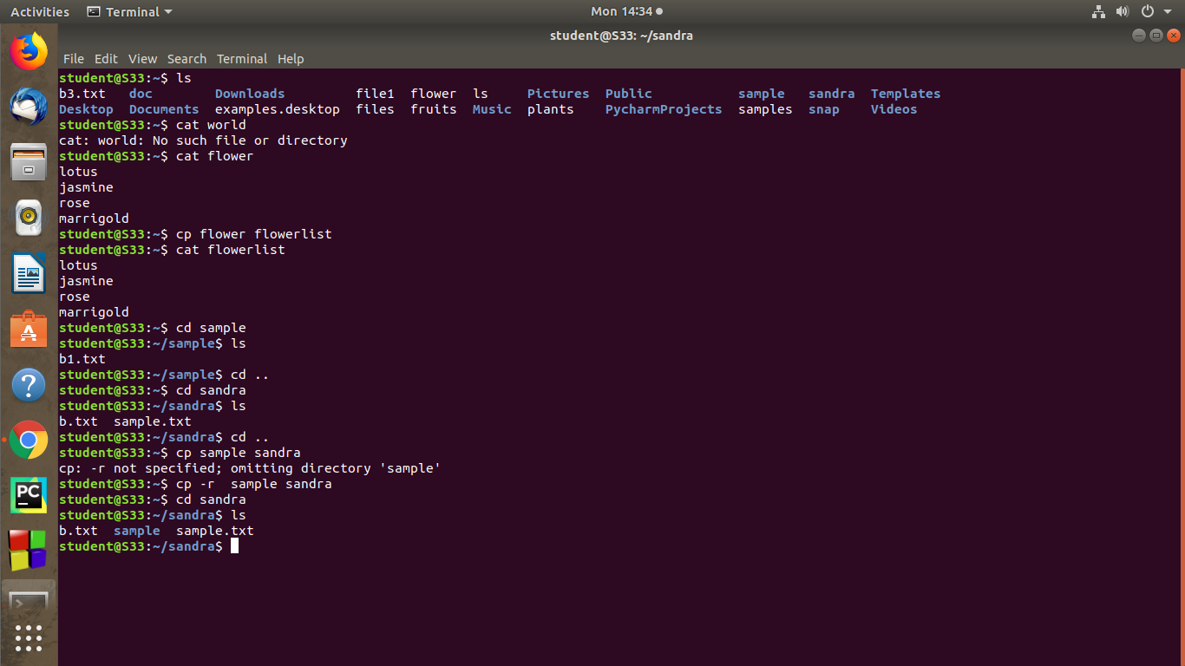

2. **cp -r**  - cp -r command is used to copy entier directory.

**Syntax:**

$cp -r – sample sandra

**output:**



3. **cp -i** – this command is used to ask permission to overwrite

**syntax:**

cp -i doc1.txt sample

**output :**

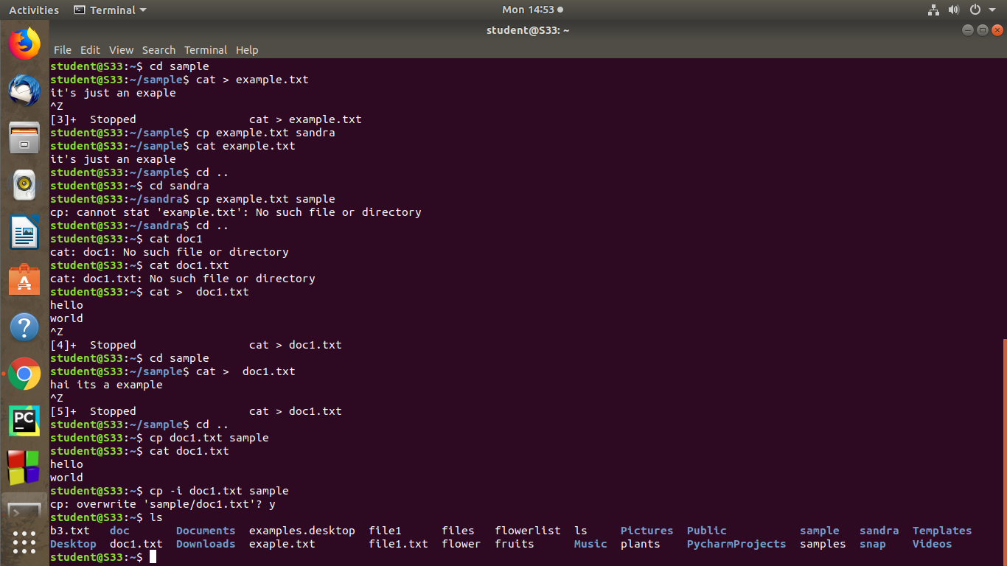

4.**mv** – mv command is used to move a file to another directory

**syntax:**

**$**mv b3.txt doc

**output:**

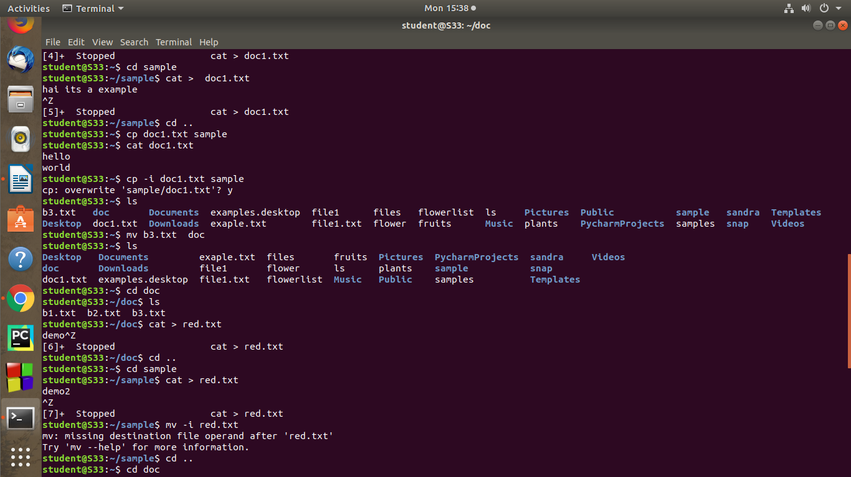

**5.mv -i -** this command is used to ask permission to move one directory to another

directory .

Syntax:

$mv -i red.txt sample

**output:**

